Vittra APS Unique Flow

THE CHAMELEON EFFECT YOU ALREADY KNOW, WITH THE FLOW THAT YOU NEED.
• No need for shade selection;
• Increased productivity;
• Reduced stock;
• Ideal flow: do not leak;
• Easy to visualize: the opaque shade before polymerization facilitates the visualization of the margins of the preparation;
•Chameleon effect: captures and reflects tooth shade precisely..
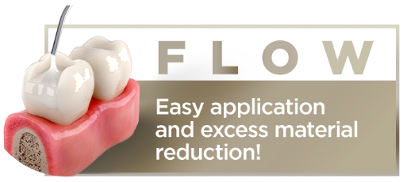
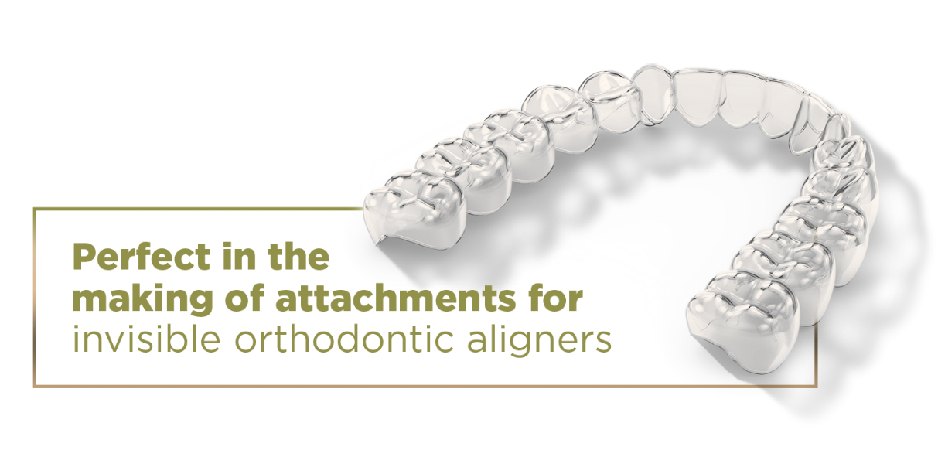
THE REAL CHAMALEON EFFECT:
The chameleon effect happens in function of the chromatic mirroring features of the composite which is capable of capturing and reflecting the shade of the dental substrate.
BEFORE
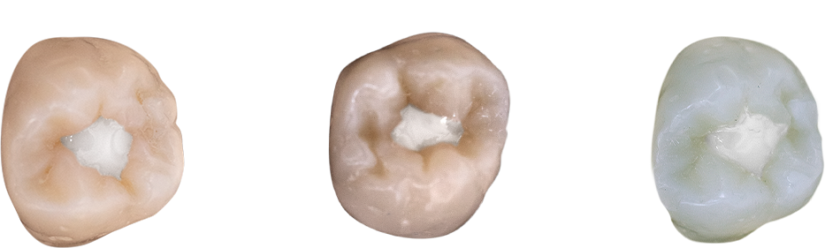
Before polymerization, the contrast and the opaquer shade of the composite facilitate the visualization and control of the restorative process.
AFTER
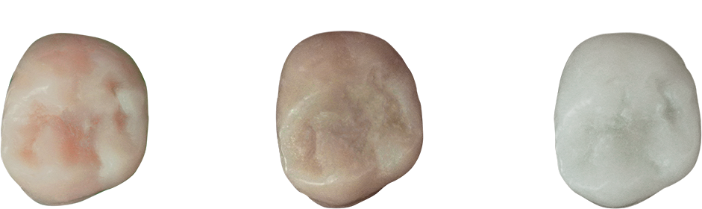
The optical properties of Vittra APS Unique Flow are defined after its polymerization. The loads, well dosed opacity and the esthetic of the APS system are critical for reaching the perfect mimicking.
RECOMMENDATIONS
 | Support for direct restorations  Seal for pits and fissures  Preparation of small defects on the enamel  Repairs on composite  Making of attachments for invisible orthodontic aligners
 | Restorations with minimally invasive cavity preparations  Tunnel type preparations  Cementing teeth fragments  Non-carious cervical lesions

APS TECHNOLOGY DIFFERENTIALS
The FGM exclusive APS technology (Advanced Polymerization System), consists in an innovating combination of colorless photo-initiators which interact with one another and allow for the amplification pf the polymerization capacity of the materials, having a positive impact on several aspects:
• Longer working time even under the reflector light;
• More efficient photopolymerization;
• Increased mechanical properties;
• Long-lasting clinical restorations;
• High esthetics and perfect mimicking.

SCIENTIFIC PROOF

Curing depth
According to ISO 4049 standard
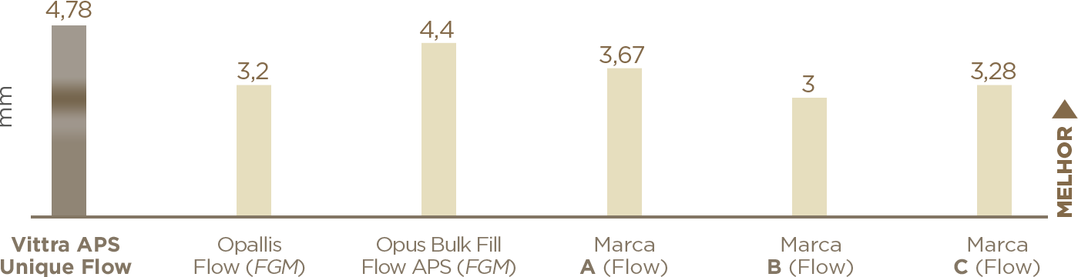
The curing depth of Vittra APS Unique Flow is superior to all 4 main competing products analyzed, an important indication for the clinical success of restorations.

Bending
ISO 4049: 80MPa minimum
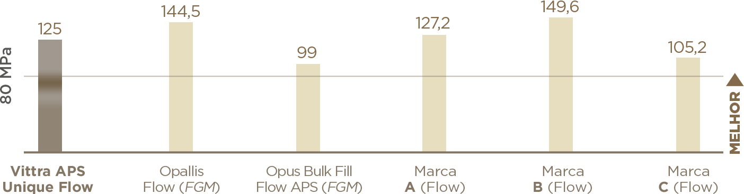
Vittra APS Unique Flow is way above the reference established by the ISO 4049 standard (>80MPa), which confirms its capacity to stand the stress resulting from the masticatory forces.

Contraction Tension
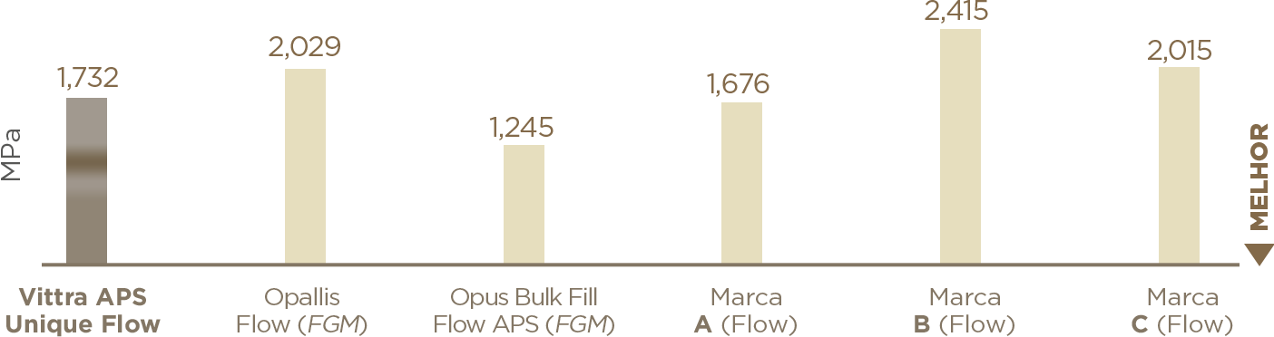
Vittra APS Unique Flow showed a result equivalent to the average performance of the main four competitors. The lower the contraction and tension generated, the lower the risk of marginal infiltration and greater the longevity of the restoration.
Source: internal tests.

Benefits:
Chameleon effect: happens in function of the chromatic mirroring features of the composite which is capable of capturing and reflecting the shade of the dental substrate.
Universal-chroma: From bleach to D4 with only one composite, for anterior and posterior teeth.
BPA-free ensuring safety and health: Studies show the interference of the compound Bisphenol-A (BPA) in the endocrine system and in fetal and childhood development, besides reproductive issues. Although the amount of BPA released in saliva by resinous materials is thousands of times lower than the minimum safest dose, there is a trend to eliminate BPA from restorative dental products.
APS Technology: Longer working time in illuminated operative ambient. Total predictability of shade even before photopolymerization. Increased mechanical properties. Compatible with all blue light-emitting light-curing devices.
Making of attachments for invisible orthodontic aligners.
Easy to visualize: the opaque shade before polymerization facilitates the visualization of the margins of the preparation.
Ideal flow: does not run off.

Recommendations
Support for direct restorations
Seal for pits and fissures
Preparation of small defects on the enamel
Repairs on composite
Making of attachments for invisible orthodontic aligners
Restorations with minimally invasive cavity preparations
Tunnel-type preparations
Cementing teeth fragments
Non-carious cervical lesions

https://fgmdentalgroup.com/international/aesthetics-products/vittra-aps-unique-flow

